

Course no: CSE 3104

Course Title: Peripherals and Interfacing Laboratory

**Project Title: Automated Hand Sanitizer Machine**

Report submission date: 7th June 2023

Submitted by:

Sadia Afrin (1907037)

&

Arpita Kundu (1907050)

**Objectives:**

The objectives of the automated hand sanitizer system are as follows:

1. Provide a touchless solution for hand sanitization to minimize the risk of cross-contamination.
2. Dispense an appropriate amount of sanitizer to optimize usage and reduce waste.
3. Ensure user-friendliness through a manual activation/deactivation switch.
4. Monitor the sanitizer level to inform users of the remaining quantity.

**Introduction:**

Hand hygiene plays a crucial role in preventing the spread of germs and maintaining public health. An automated hand sanitizer system was developed in response to the need for touchless and efficient hand sanitization. This report provides an overview and evaluation of the system, including its objectives, system overview, component details, working procedure, and a discussion on its effectiveness.

**System Overview:**

The automated hand sanitizer system consists of the following components:

* **Arduino Uno:** Acts as the brain of the system, executing programmed instructions and coordinating component interactions.
* **Ultrasonic Sensor:** Utilizes sound waves to measure the distance between the sensor and the user's hand.
* **Relay:** Serves as an electrically controlled switch, enabling or disabling power flow to the pump motor.
* **Pump Motor:** Activates to dispense sanitizer onto the user's hand when triggered.
* **Switch:** This enables users to manually activate or deactivate the dispenser.
* **Battery:** Supplies power to the system components for independent operation.

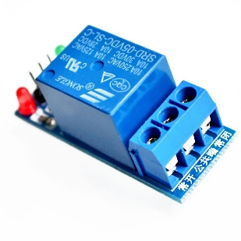 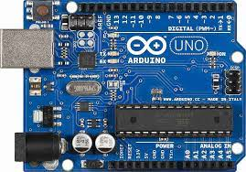 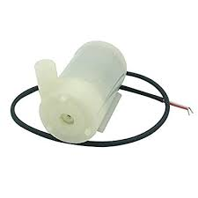

Relay

Pump Motor

Arduino UNO

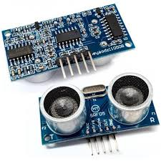 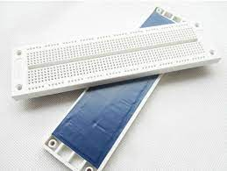 

Ultrasonic Sensor

Electric Pushable Switch

Bread Board

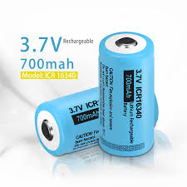 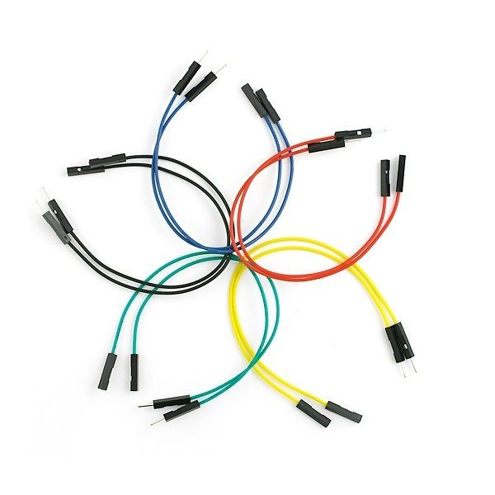

#.7V Lithium Ion Battery

Jumper Wire

**Circuit Diagram:**

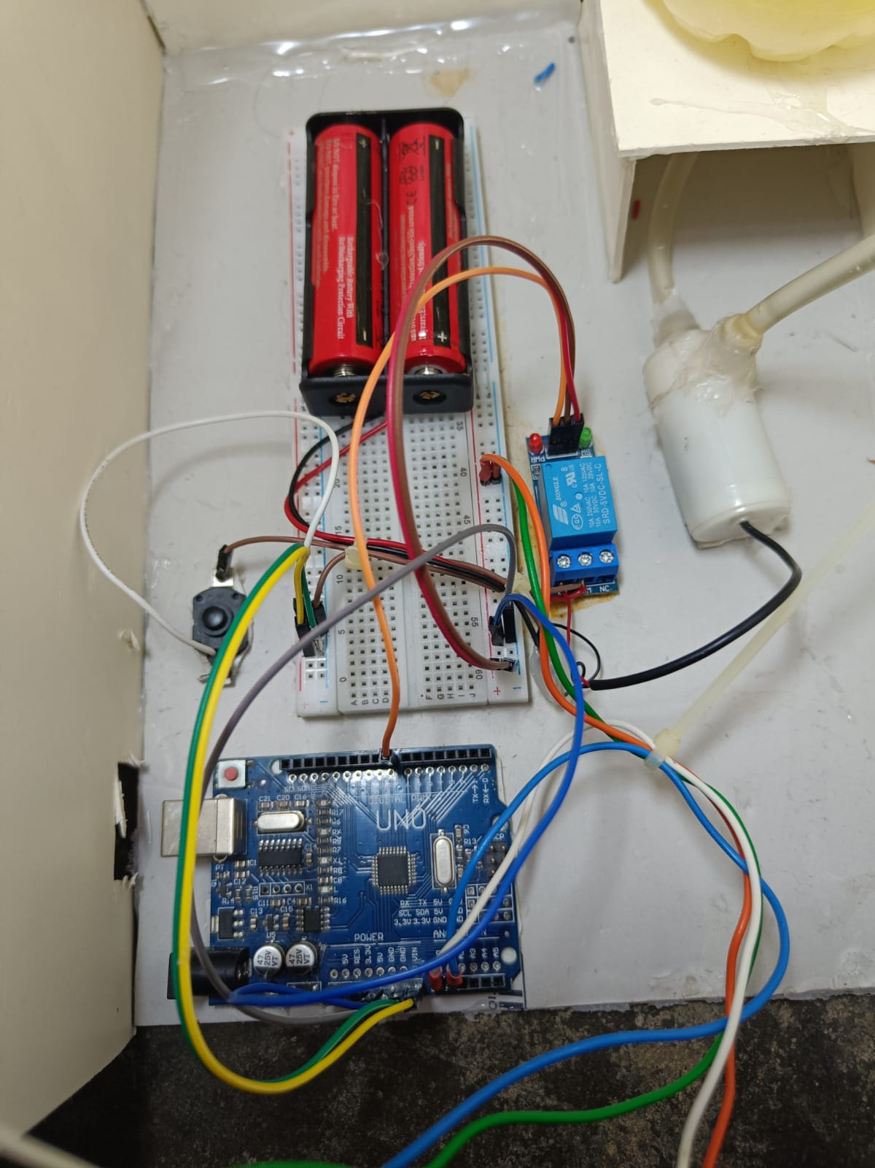

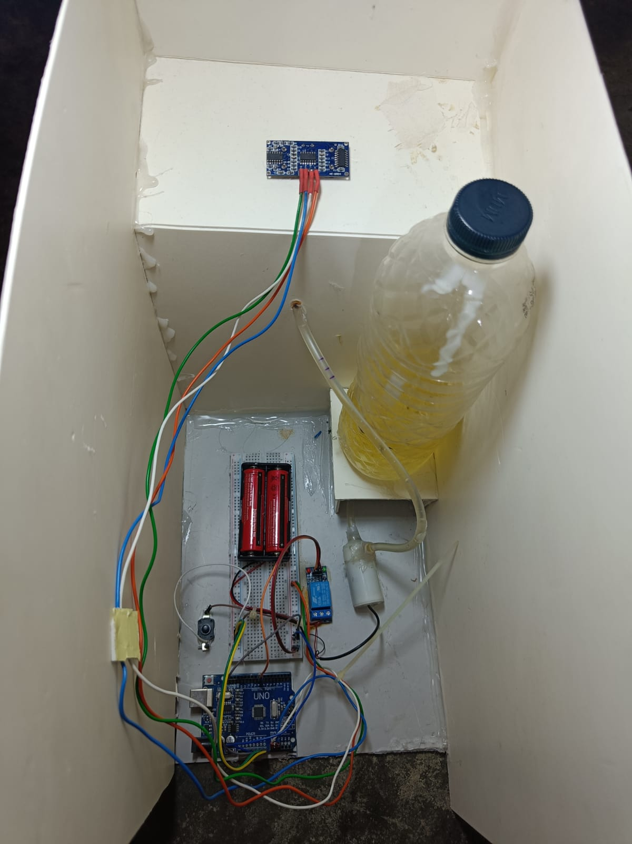

**Methodology:**

The automated hand sanitizer system follows these steps:

1. The ultrasonic sensor continuously measures the distance between the user's hand and the sensor.
2. Upon activating the switch and ensuring sufficient sanitizer level, the system checks if the measured distance is within the predefined threshold for activation.
3. The relay triggers the pump motor if the distance falls within the threshold and sanitizer is available.
4. The pump motor runs for a specified duration, dispensing an appropriate amount of sanitizer onto the user's hand.
5. The sanitizer level is updated based on the amount used, and the system remains deactivated until the switch is turned on again.

**Flow Chart:**

Start

Initialize the pin assignments for trigPin, echoPin, and pumpPin

Set the initial duration and distance values to 0

Add Delay

Set trigPin

to LOW

Add Delay

Set trigPin

to LOW

Define "dis" Function

Print Distance on Serial Monitor

Calculate

distance

Measure duration

Set trigPin

to LOW

Set up Arduino

Set pumpPin as OUTPUT

YES

Turn on Pump

(set pumpPin to LOW)

Set Initial Pump State

If distance<17 & distance>10

Call “dis” function

Main Loop

NO

Turn off Pump

(set pumpPin to HIGH)

End

**Pseudocode:**

*Declare and initialize constants:*

trigPin = 14

echoPin = 15

pumpPin = 8

*Declare variables:*

duration

distance

*Function:*

dis

Set trigPin to LOW

Delay for 2 microseconds

Set trigPin to HIGH

Delay for 10 microseconds

Set trigPin to LOW

Read the duration using pulseIn function on echoPin with HIGH state

Calculate distance as duration * 0.034 / 2

Print distance on the Serial Monitor

*Setup:*

Set trigPin as OUTPUT

Set echoPin as INPUT

Begin serial communication at 9600 baud

Set pumpPin as OUTPUT

Set pumpPin to HIGH (turn off the pump initially)

*Main Loop:*

Call ‘dis’ function to measure distance

Check if distance is less than 17 and greater than 10

If true:

Set pumpPin to LOW (turn on the pump)

Else:

Set pumpPin to HIGH (turn off the pump)

**Discussion:**

The automated hand sanitizer system offers several key advantages for promoting hand hygiene. The touchless operation minimizes the risk of cross-contamination, particularly in high-traffic areas. The system's accurate measurement of distance ensures the appropriate amount of sanitizer is dispensed, reducing waste. The manual activation/deactivation switch enhances user-friendliness. However, potential improvements include incorporating safety measures and enhancing sanitizer-level monitoring through dedicated sensors or integration with smart monitoring systems.

**Conclusion:**

In conclusion, the automated hand sanitizer system provides a convenient and hygienic solution for hand sanitization. Through touchless operation, efficient dispensing, and user-friendliness, it effectively promotes hand hygiene practices. While improvements can be made, such as incorporating safety measures and enhancing sanitizer level monitoring, the system demonstrates the potential for automation to contribute to cleanliness and germ control in various settings. With further development, the automated hand sanitizer system can play a vital role in ensuring public health and hygiene.